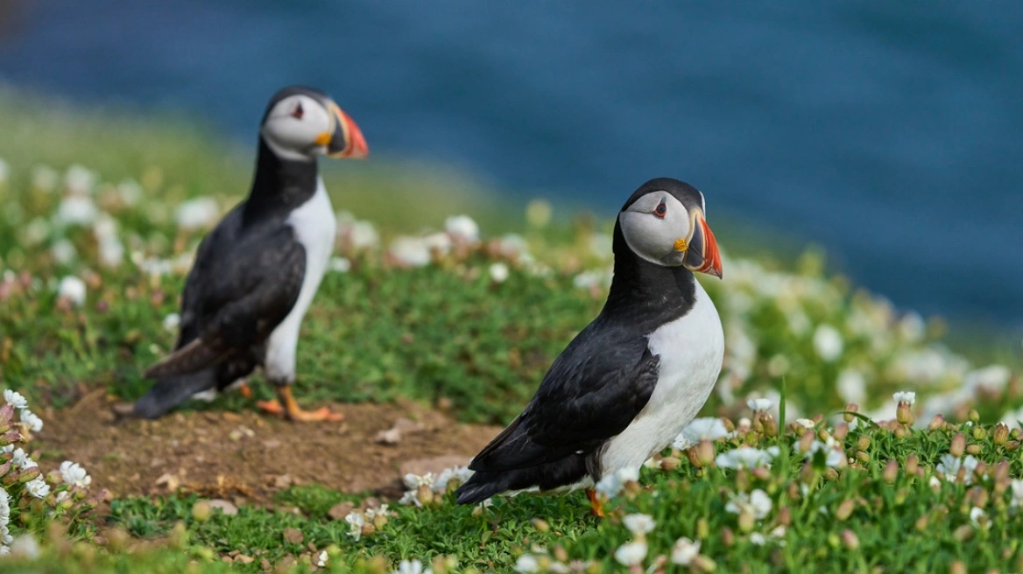

Assignment: Counting puffins is an important conservation task. To assist human volunteers, you are being asked to develop an automated counting algorithm.
- Motivate which approach or learning model you would propose to use.
(20 points)
- Describe how you would collect a dataset for training, validation, and testing with concrete numbers. Provide detailed examples how type of annotations you would require.
(30 points)
- Provide at least three example images on which you expect the algorithm to fail. Comment why you think the algorithm would fail to estimate the correct number of samples for a given image. These scenarios should cover different failure modes. Please include example image in your text.
(30 points)
- Outline a short plan how you would deploy the algorithm. Volunteers will provide the images on their cell phones.
(20 point)

